Module – 1 Compute

**Assignment 4:** Host and Deploy an application using Elastic Beanstalk

Synopsis: Create your example application, you'll use the Create a web app console wizard. It creates an Elastic Beanstalk application and launches an environment within it. An environment is the collection of AWS resources required to run your application code.

AWS Elastic Beanstalk is an easy-to-use service for deploying and scaling web applications and services developed with Java, .NET, PHP, Node.js, Python, Ruby, Go, and Docker on familiar servers such as Apache, Nginx, Passenger, and IIS.

You can simply upload your code and Elastic Beanstalk automatically handles the deployment, from capacity provisioning, load balancing, auto-scaling to application health monitoring. At the same time, you retain full control over the AWS resources powering your application and can access the underlying resources at any time.

Below are the steps for the assignment:

Step 1: Look for the ‘**Elastic Beanstalk’** in AWS Console search box.

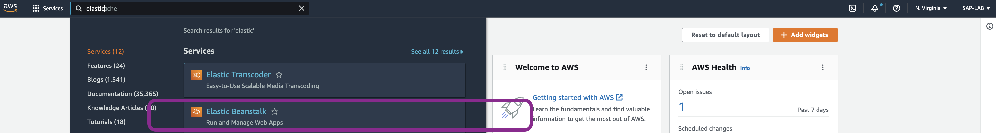

Step 2: If we haven’t created any application previously, we will get dashboard like below. Click on **‘Create application’**

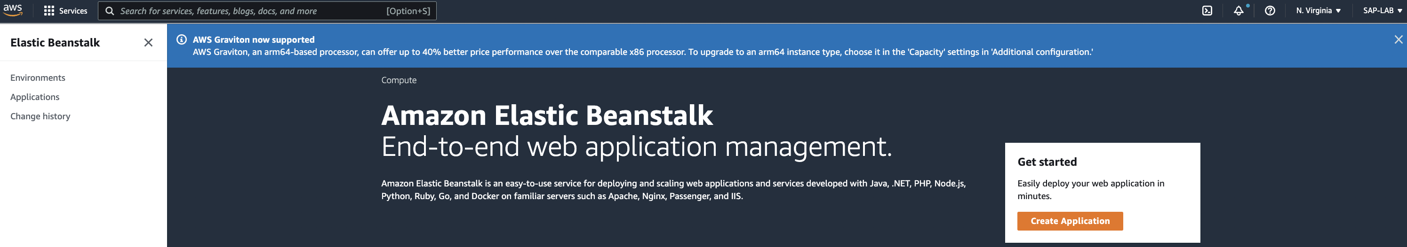

Step 3: Configure the below mentioned properties

1. Application Name: provide the name for your application
2. Tags: As tags are optional properties can be left as it is.
3. Platform: Choose the language of your application
4. Application Code: To deploy our example application we chose ‘Sample Code’. To upload our code click on ‘Upload your code’

Click on ‘Create Application’.

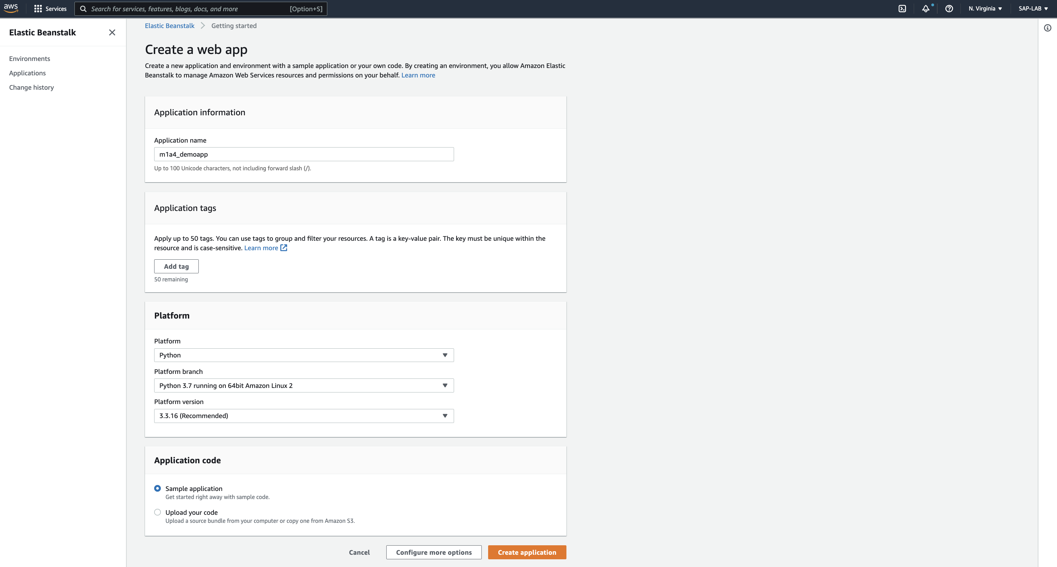

After clicking on ‘Create application’ we will get logs of every action being performed by AWS Service to create and deploy the application.

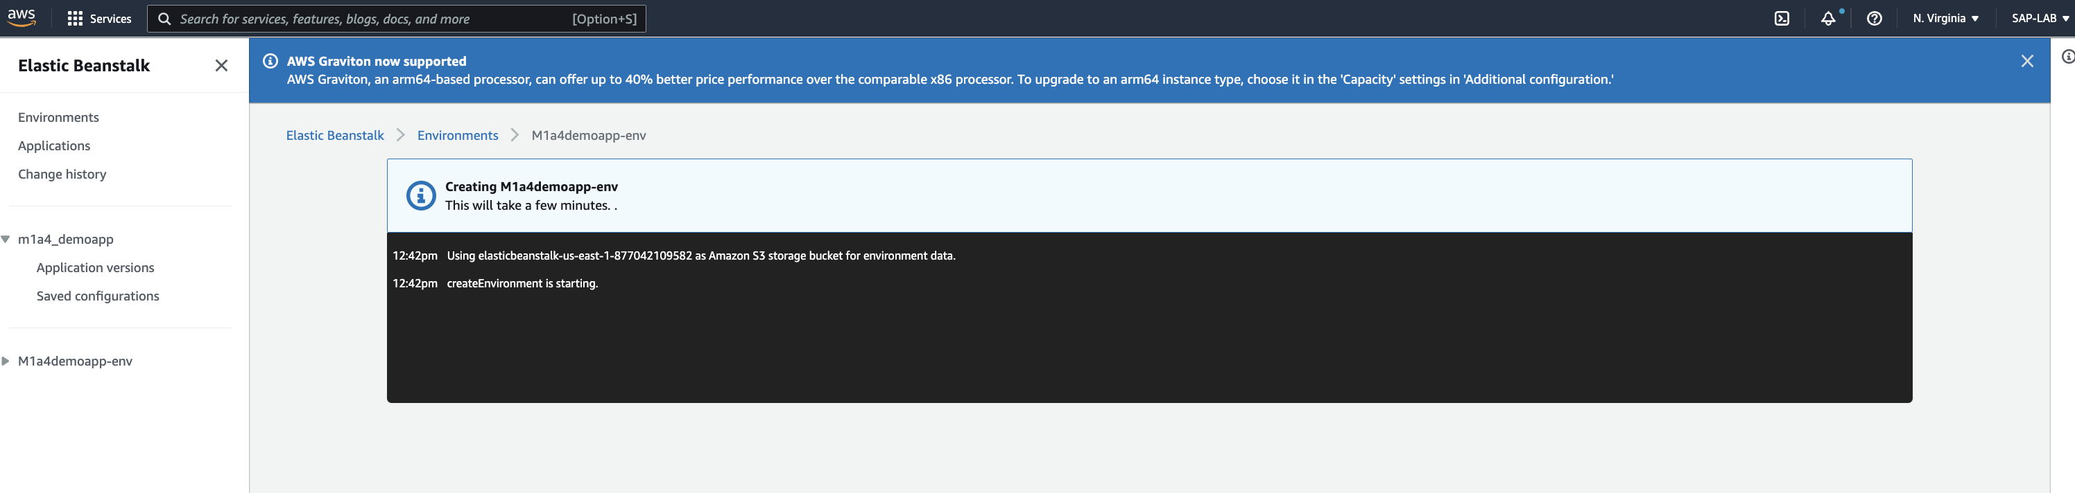

Upon successful deployment we will get ‘OK’ state for application health.

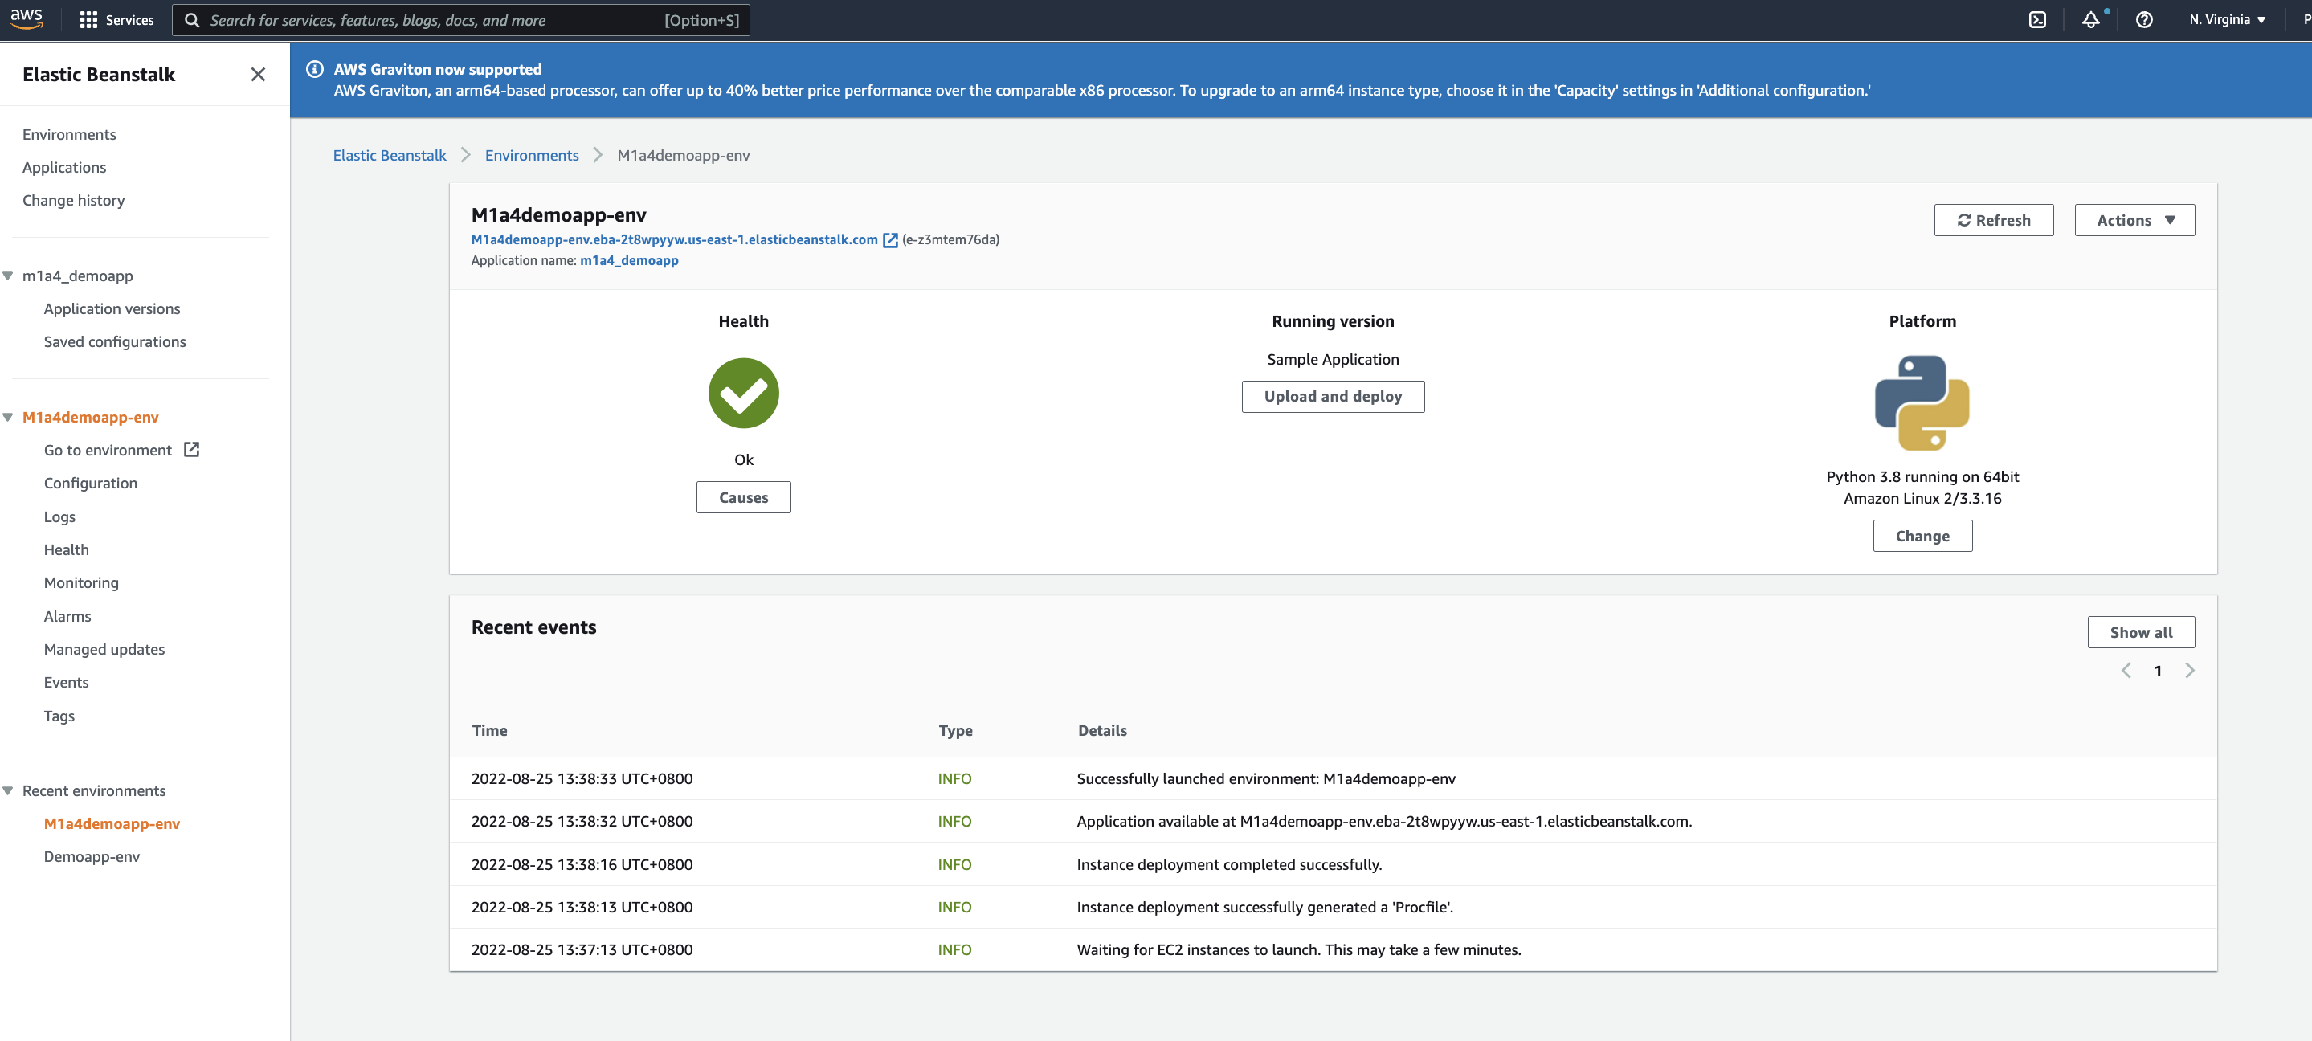

Step 4: Click on the URL to test the application:

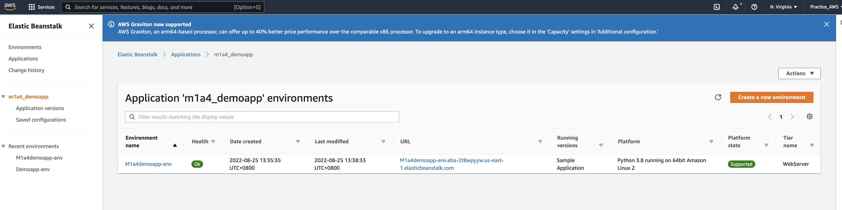

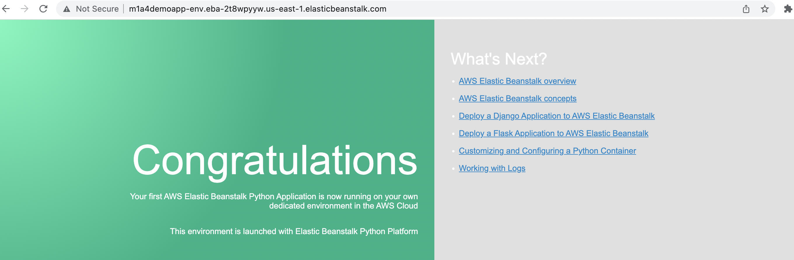

As we have created application for the first time, while creating application it will launch the Environment also.

To create a new Environment, click on newly created application. We will get option to create ‘New Environment’.